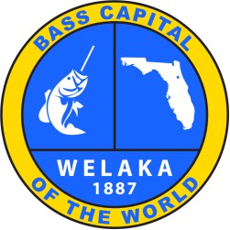
TOWN OF W TOWN OF WELAKA

TOWN COUNCIL SPECIAL MEETING
AGENDA

June 16, 2025, at 6 PM

Honorable Willie Washington, Jr. Town Council Room 400 4th Avenue, Welaka, FL 32193

- CALL TO ORDER, PLEDGE OF ALLEGIANCE & INVOCATION

- ROLL CALL

- Approval of Agenda

- Explain evaluation form and questions

- Interview process of applicants

- Interview applicants

- Total points

- Announce the applicant with the most points from the Evaluation Form

- Adjourned

